1. More about JList.

In Unit 4 we used the Jlist class. To instantiate it we used an array of strings. But we can use another class that makes the Jlist are dynamic objects to which you can add and remove elements at runtime, for this you must use a DefaultListModel:

DefaultListModel listModel = new DefaultListModel ();
listModel.addElement ("Jane Doe");
listModel.addElement ("John Smith");
listModel.addElement ("Kathy Green");

JList list = new JList (listModel);

In this way we can add or remove elements at runtime using the following methods of the DefaulListModel, being immediately reflected in the JList:

// remove element 0 from the DefaultListModel
listModel.remove (0);

// get the size of the DefaultListModel
int size = listModel.getSize ();

// return element 1 of the DefaultListModel
String s = listModel.get (1)

For a complete example of using Jlist with DefaulListModel, see example in this unit. It is a NetBeans project that looks like this:

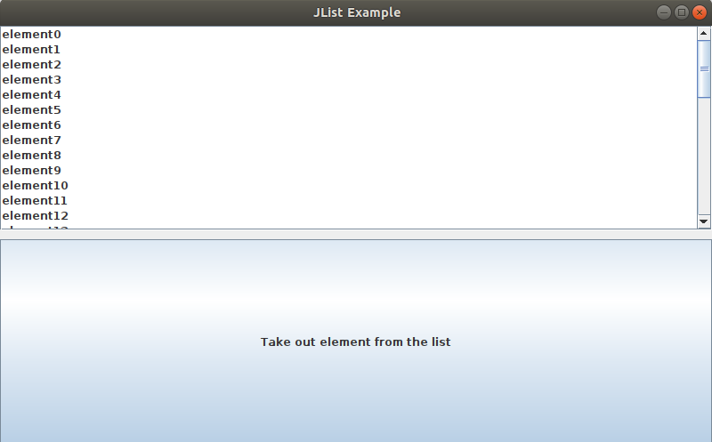

Look at the code, how the Jlist is treated. It is a simple code and it is commented.

2. An exercise with Jlist.

Using this new knowledge of the Jlist we will carry out the following exercise:
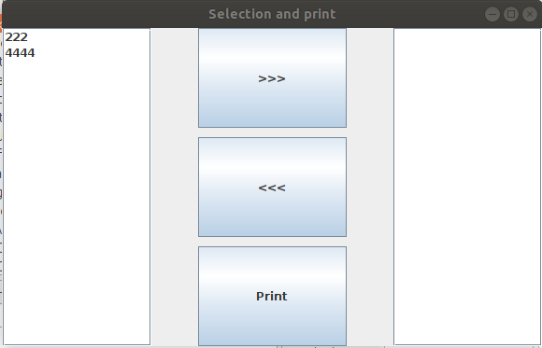

- We have two Jlist and three buttons.
- In the first Jlist there are some elements. These are the id fields of the clients table of the di database that we used in unit 7. In the window constructor we must go through that table and add the id fields to the DefaulListModel associated with the Jlist. In my case, this is the data it contained:
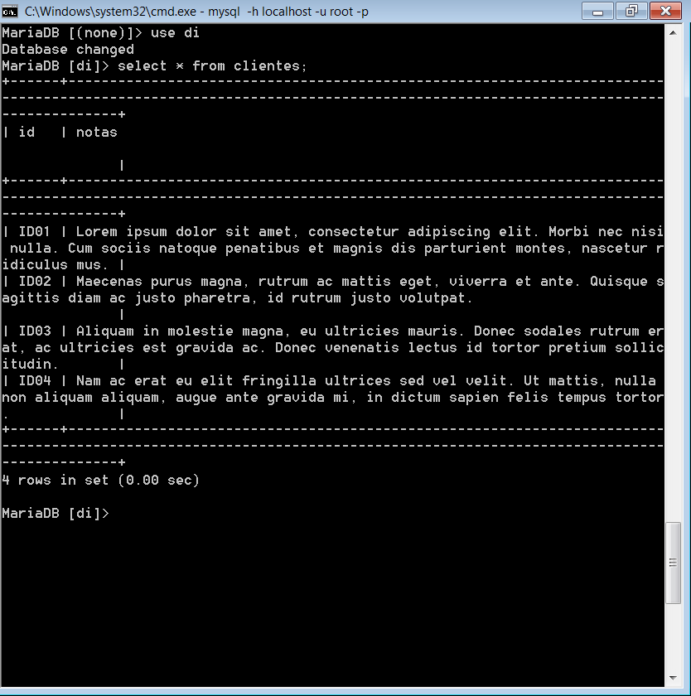

- The >>> button will cause the selected element to go from the first jlist to the second:

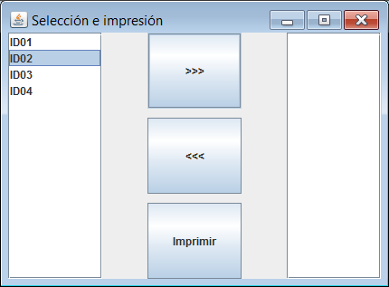
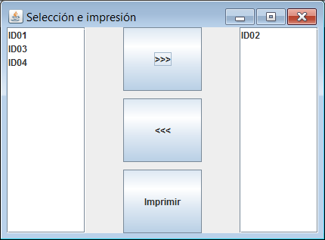

- The <<< button will do the opposite effect:

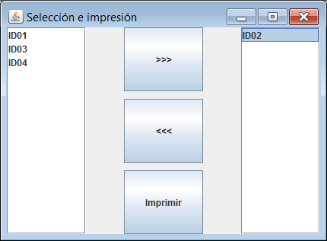
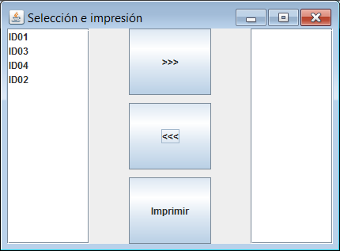

- We will select those Id that we want to print, for example:

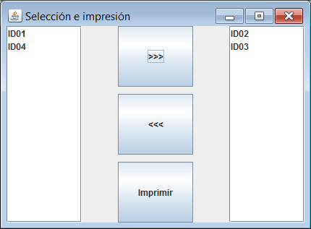

- When we click on the print button it will cause a listing like the following to print:

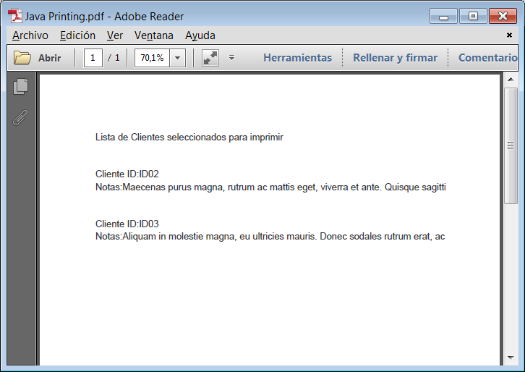

- To make the printing we will use a JtextArea just like we did in unit 8. It is also convenient to have a pdf printer installed on our computer to see the printing results.

